Chinese NLP:

Cannot resolve GG…

Play + laugh to cry emoji => joke + cry + ‘R’

Solution: find the emoji pattern and remove

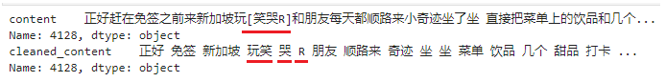

Solution: only correct the top 50??

